**Pituitary pathology**

The pituitary gland is a small, bean-shaped structure that lies at the base of the brain within the confines of the sella turcica. It is intimately related to the hypothalamus, with which it is connected by a stalk*,* composed of axons and a rich venous plexus.

The pituitary is composed of two distinct components: the anterior lobe (adenohypophysis) and the posterior lobe (neurohypophysis). The anterior pituitary, or adenohypophysis, produces trophic hormones that stimulate the production of hormones from the thyroid, adrenal, and other glands. The release of these pituitary hormones is under the control of factors produced in the hypothalamus.

Symptoms and signs of pituitary disease fall into the following categories:

1. Hyperpituitarism
2. Hypopituitarism
3. Local mass effects

**Pituitary Adenoma**

**General Features**

The most common cause of hyperpituitarism is a hormone-producing adenoma arising in the anterior lobe. Other, less common, causes include hyperplasia and carcinomas of the anterior pituitary.

* Pituitary adenomas are designated as *microadenomas* if they are less than 1 cm in diameter and *macroadenomas* if they exceed 1 cm in diameter.
* Pituitary adenomas can be *functional* (hormone producing) or *nonfunctioning* (not producing hormone).
* Nonfunctioning adenomas are likely to come to clinical attention at a later stage and are, therefore, more likely to be macroadenomas.
* Pituitary adenomas are classified on the basis of hormone(s) produced by the neoplastic cells (see table 20.1).

**Pathogenesis**

G-protein mutations are one of the most common genomic alterations in pituitary adenomas. The α-subunit of G-protein (Gsα) is encoded by the *GNAS* gene. On interaction with the ligand, the activation of Gsα results in the generation of cAMP, promoting cellular proliferation and hormone synthesis and secretion.

Approximately 40% of somatotroph cell adenomas bear GNAS mutations with constitutive activation of Gsα, persistent generation of cAMP, and unchecked cellular proliferation.

**Morphology**

The usual pituitary adenoma is a well-circumscribed, soft lesion. Small tumors may be confined to the sella turcica, while larger lesions may compress the optic chiasm and adjacent structures. In 30% of cases, the adenomas are non-encapsulated and infiltrate adjacent bone, dura, and brain.

Pituitary adenomas are composed of relatively uniform, polygonal cells arranged in sheets, cords, or papillae. The nuclei of the neoplastic cells may be uniform or pleomorphic. The cytoplasm of the constituent cells may be acidophilic, basophilic, or chromophobic, depending on the type and amount of secretory product within the cell.

Mitotic activity usually is scanty.

This cellular monomorphism and the absence of a significant reticulin network distinguish pituitary adenomas from normal anterior pituitary parenchyma.

The functional status of the adenoma cannot be predicted from its histologic appearance.

**Hyperpituatarism**

**Functioning Adenomas**

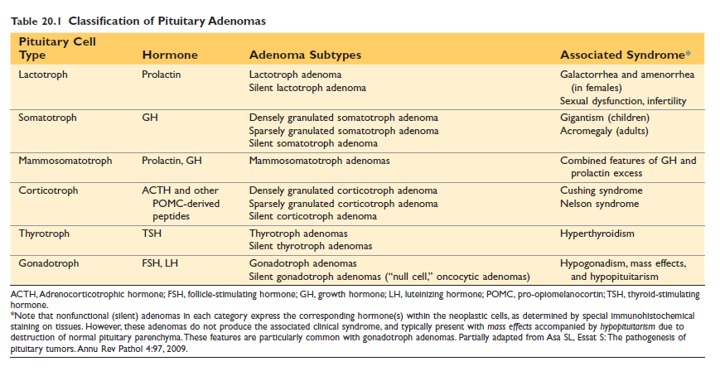

**Lactotroph Adenoma**

Prolactin-secreting lactotroph adenomas are the most frequent type of hyperfunctioning pituitary adenoma, accounting for about 30% of all clinically recognized cases. They range in size from microadenomas to large expansile tumors associated with considerable mass effect.

**Somatotroph Adenoma**

Growth hormone–secreting somatotroph adenomas are the second most common type of functioning pituitary adenoma, and cause gigantism in children or acromegaly in adults.

Persistent growth hormone excess stimulates the hepatic secretion of insulin-like growth factor 1 (IGF1), which acts in conjunction with growth hormone to induce overgrowth of bones and muscle.

If a growth hormone– secreting adenoma develops before the epiphyses close, as is the case in prepubertal children, excessive levels of growth hormone and IGF1 result in **gigantism**. This condition is characterized by a generalized increase in body size, with disproportionately long arms and legs.

If elevated levels of growth hormone and IGF1 persist or develop after closure of the epiphyses, affected individuals develop **acromegaly**, in which growth is most conspicuous in soft tissues, skin, viscera, and the bones of the face, hands, and feet.

**Hypopituitarism**

Clinically significant hypopituitarism may occur with loss or absence of 75% or more of the anterior pituitary parenchyma.

1. Most cases of anterior pituitary hypofunction are caused by pituitary disorders:

* Nonfunctioning pituitary adenomas
* Ischemic necrosis of the anterior pituitary*,* called *Sheehan syndrome,* or postpartum necrosis of the anterior pituitary, is the most common form of clinically significant necrosis of the anterior pituitary. During pregnancy, the anterior pituitary enlarges, mainly because of an increase in the size and number of prolactin-secreting cells. This hyperplasia is not accompanied by an increase in blood supply from the hypophyseal portal venous system. The enlarged gland is thus vulnerable to ischemic injury, especially in women who experience hypotension during the peripartal period.
* Iatrogenic causesinclude ablation of the pituitary by surgery or radiation
* Other, less common causes of anterior pituitary hypofunction include inflammatory lesions such as sarcoidosis or tuberculosis, trauma, and metastatic tumors involving the pituitary

2. Less frequently, disorders that interfere with the delivery of pituitary hormone–releasing factors from the hypothalamus, such as hypothalamic tumors, cause hypofunction of the anterior pituitary.